**Mohammed Al Madhi**

**CIS 480**

**FALL 2020**

**Homework 4 – Packet Tracer**

|  |
| --- |
| * This is an individual assignment, and is worth 20 points. * The due date is Friday, September 25 midnight. * Submit the final outcome and *.pkt file. * Follow usual naming convention. * Copying and submitting someone else’s work is strictly prohibited. If caught, the students (giver and receiver) will receive zero on this assignment and also a 20 points penalty. |

**Task 1**. Complete all the Parts in the following file: *2.1.1.5 Packet Tracer - Create a Simple Network Using Packet Tracer.pdf*.

* Ping **Laptop** from **PC** and take a screenshot of the outcome. You should try the IP address of the Laptop.

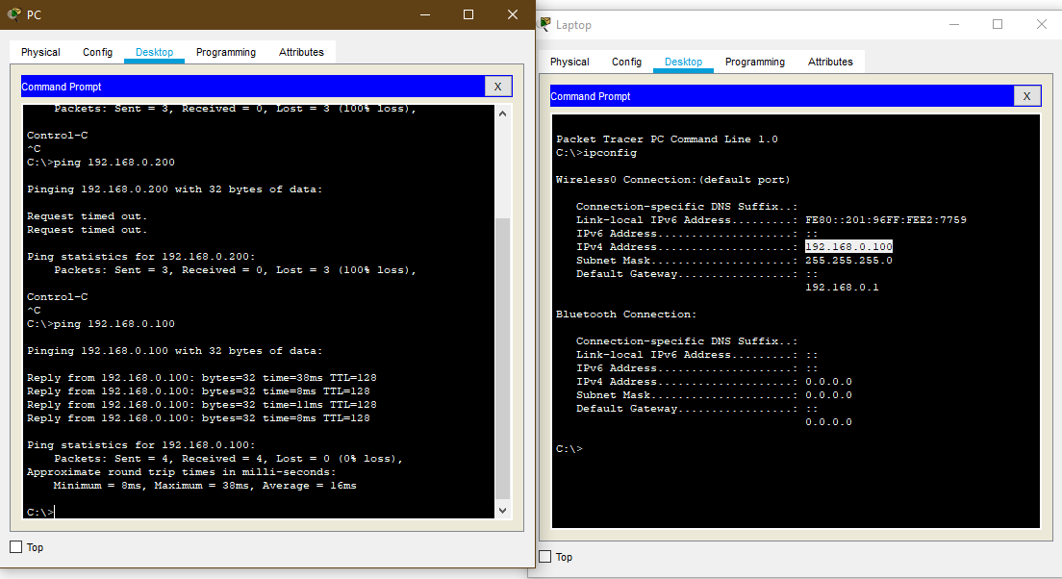

* Ping **Cisco.com** from **PC** and take a screenshot of the outcome (refer to p. 14).

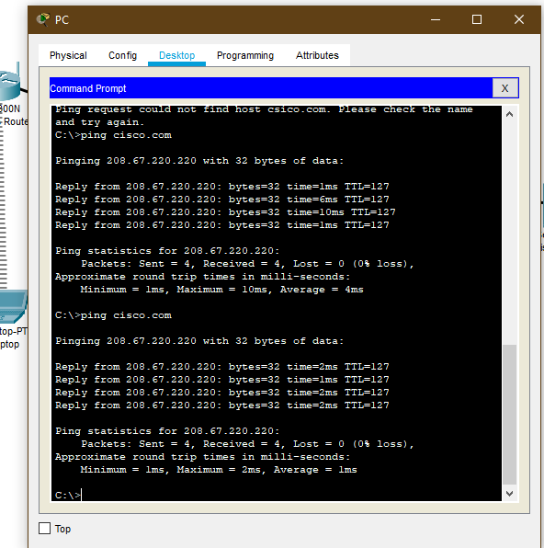

**Task 2.** Change the name of the network devices.

* Ping **Laptop** from **PC** and take a screenshot of the outcome. You should try the IP address of the Laptop.

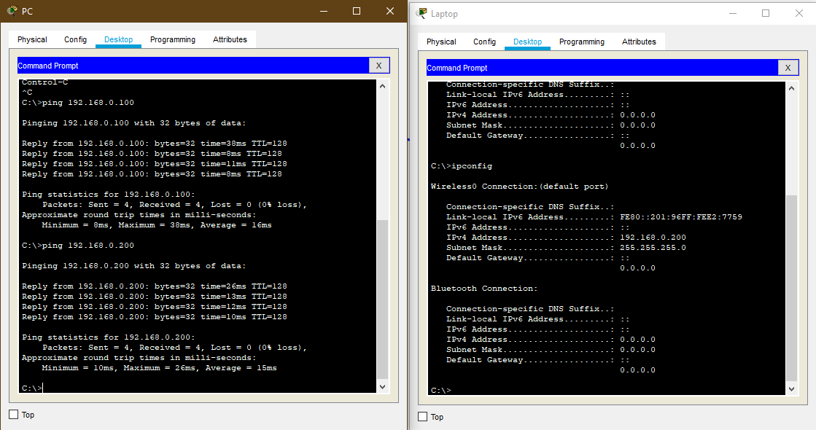

* Ping **[your last name].com** from **PC** and take a screenshot of the outcome. 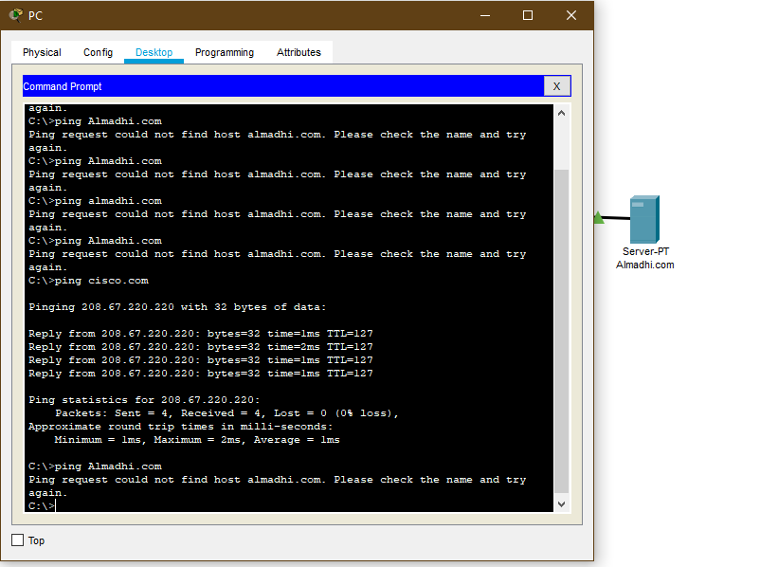

**Task 3**. Complete Parts 1 and 2 (not 3) in the following file: *3.1.1.3 Packet Tracer - Explore Network Functionality Using PDUs.pdf*.

- Take a screenshot of the **Simulation Panel** (like the one on p.4).

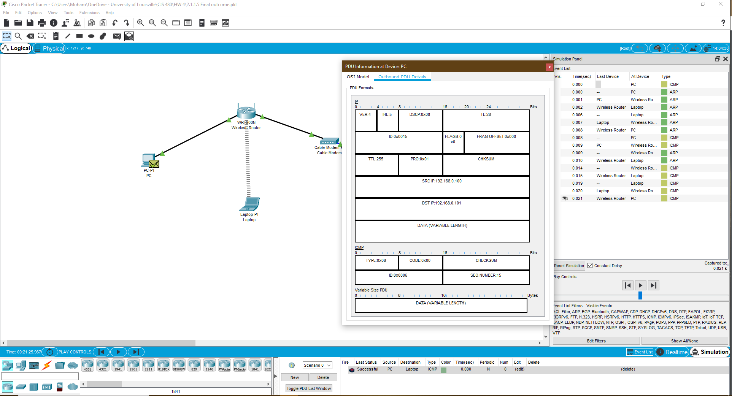

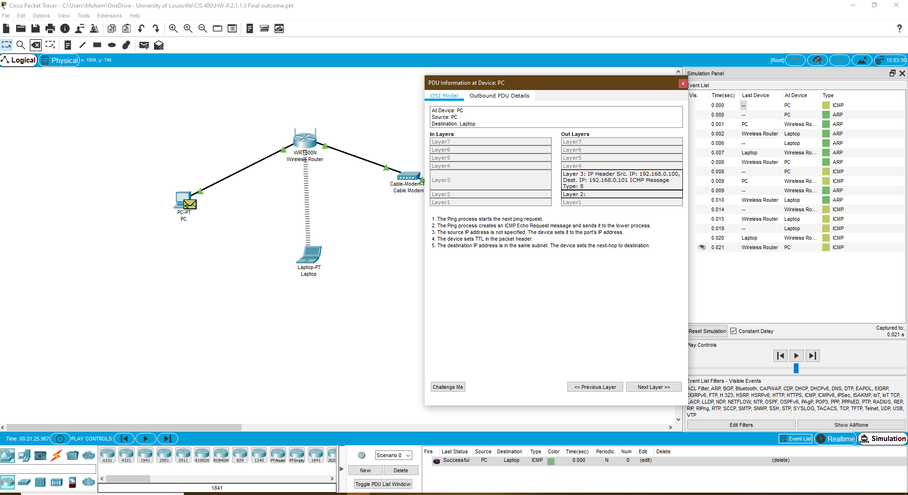

**Task 4**. Submit your *.pkt file.